**Design Documentation**

**Team Wow**

**Product: Sensory Evaluation Website**

**Helping food science with data gathering and analysis software**

**Team members:**

**Connor Taylor**

**Shaina Greer-Short**

**Frank Senseney**

**Geoff Worley**

**2/7/2018**

**Table of Contents**

Table of Contents………………………………………………………………………………………………………………………….…….. 2

1. Introduction…………………………………………………………………………………………………………………….………… 3
   1. Purpose…………………………………………………………………………………………………………………....………… 3
   2. Scope…………………………………………………………………………………………………….………………….………… 3
   3. Definitions, Acronyms, and Abbreviations…………………………….………………………………….………… 3
   4. References………………………………………………………………………………………………….…………….………… 3
   5. Overview……………………………………………………………………………………………………….………….………… 3
2. Work Flow……………………………………………………………………………………………………….…………..….………… 4
   1. Create Test………………………………………………………….……….………………………………….………….……… 5
3. Database Design…………………………………………………...……….………………………………….……..……….……… 6
   1. Test Table…………………………………………………...……….………………………………….………………….……… 6
   2. Intensity Test Table…………………………………………...……….…………………………………...………….……… 6
   3. Difference Test Table………………………………………...……….………………………………….………….…..…… 6
4. User Design………………………………………...……….…………………………..………………………….………….…..…… 7
   1. Administrative User…………………………………………………………..………………..……….………….…………. 8
   2. Account User…………………………………………………………..………………..……….…………………………..…… 9
   3. Non-Account…………………………………………………………..………………..……….………….…..……………..… 9
5. Input Authentication…………………………….…………………………………………..….…..……….………….…..…… 10
6. Appendix………………………………….………………………………………………………………………………….…..……… 11
7. **Introduction**
   1. **Purpose**

The purpose of this design documentation is to layout the design of the website made for Dr. Gee with the purpose of helping food science with data gathering and analysis. This design documentation is for the reference of the programming team which contains Shaina Greer-Short, Frank Senseney, Geoff Worley, and Connor Taylor. It is also for the project advisor, Szilard Vajda, and the client David Gee.

* 1. **Scope**

The software product to be produced is a website called “Sensory Evaluation”. Sensory Evaluation will allow users to create sensory evaluation tests (see section 1.3) that can be used by judges when judging food samples for certain qualities. Currently, judgements are written on paper and transcribed into spreadsheets for Microsoft Excel. The objective of this product will be to automate this process of gathering and organizing data from sensory evaluation tests. This data shall automatically be condensed into an Excel spreadsheet for downloading and further analysis per the goals of the Health Sciences department.

* 1. **Definitions, Acronyms, and Abbreviations**

CWU – Central Washington University

Sensory Evaluation – a scientific discipline that analysis and measures human responses to the composition of food and drink

* 1. **References**

Appendix, Document A. Questionnaire for Tenderness, 11/11/2017, Central Washington University

Appendix, Document B, Phone Screen Shot, 2/8/2018

Appendix, Document C, iPad Screen Shot, 2/8/2018

Appendix, Document D, Computer Screen Shot, 2/8/2018

* 1. **Overview**

The rest of this design documentation contains a clarification of the designs, and technical aspects of the product. Details on work flow are contained in section two. Details on design are contained in section three, and four. Details on authentication are contained in section five. Screen shots of the current website on a variety of devices and browsers can be seen in the appendix. A document containing an example of the previously used physical documents can also be found in the appendix.

1. **Work Flow**

All information created in the front-end website portion of the project is confirmed and saved in the backend database portion of the project. Correspondingly, all information displayed in the front-end website is obtained from the backend database.

Back End

Database

Front End

* 1. **Create Test**

We determined to cut up the test creation process into several parts because we believe it will make the website easier to use and learn because the user will only have to consider one aspect of their test at a time. We cut the test up into these specific parts because it allows for the test to change based on inputs (e.g. what type of test is being created will change what other questions about the test the user will need to answer).

If the type of test is “Intensity Test”

If Add Variables? Is “No”

If Add Variables? Is “Yes”

If the type of scale is “Point Scale”

1. **Database Design**

We determined to cut the tests into these specific tables for several reasons. We decided to cut the tests into two different tables (Intensity Test Table and Difference Test Table) because intensity tests and difference tests (triangle and duo/trio tests) require different inputs and so separating the tables helps remove extra empty rows that the table would otherwise contain. We decided to cut the Intensity Test table into several parts because of a one to multiple relationship. For example, one intensity test can test for several variables. Because the amount of variables that is tested for depends on the user it would not be space efficient to store the variables with the other test data, the same is true of descriptive terms in relation to variables.

Each table will have its own classes and methods to pull the user input from the website with main tables (e.g. Test, Intensity Test, etc.) calling their sub-tables classes (e.g. Intensity Test, Variable, etc.). The values in parenthesis below the name of the table are the keys that match the tables to each other so that we can reliably determine which data belongs together. The subsections her contain the different variables contained in each table, these variables are required to complete the fulfil the client’s requirements. Variable ids are automatically assigned when tests are added to the database and serve as keys.

* 1. **User Table**

|  |  |  |  |  |  |
| --- | --- | --- | --- | --- | --- |
| KeyUser id | First name | Last name | email | password | Type of user |

* 1. **Tests Table**

|  |  |  |
| --- | --- | --- |
| KeyTest id | User id | Name of Test |

* 1. **Variables Table**

|  |  |  |
| --- | --- | --- |
| Keyvariable id | Test id | description |

1. **User Design**

This design shows the hierarchy of users and what the user can see. For example, the Account user can see the Account user view and the Non-Account user vies, but cannot see the Administrative user view. The subsections here show everything the user specified in that sub-section can view.

* 1. **Administrative User**

The administrative user can access all parts of the website.

* 1. **Account User**

The Accounts user can see what they have done, but cannot access anyone else’s tests.

* 1. **Non-Account User**

The Non-Account user is anyone that attempts access to the website despite not having an account. These people can view the website and the public tests, but cannot do anything with the tests.

1. **Input Authentication**

This describes the process that every input is put through before being entered either into the excel document or the database to determine that the input is correct and will not crash the product.

**Appendix**

**Document A**

A copy of the current written judgement sheet for both the unstructured scale (above) and the point scale (below a 9-point scale).

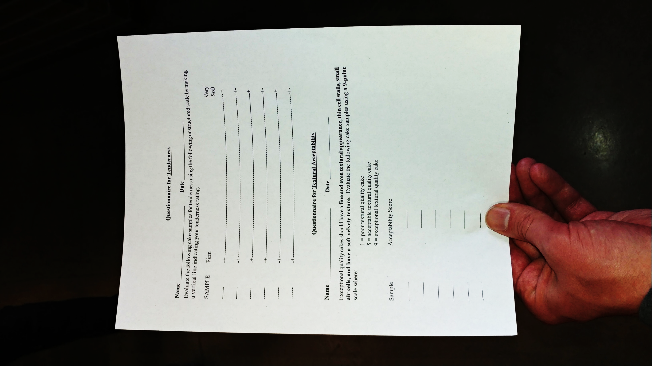

**Document B**

This is a screen shot of the main page on the website we are creating. This screen shot was taken on an Android phone in the Chrome browser.

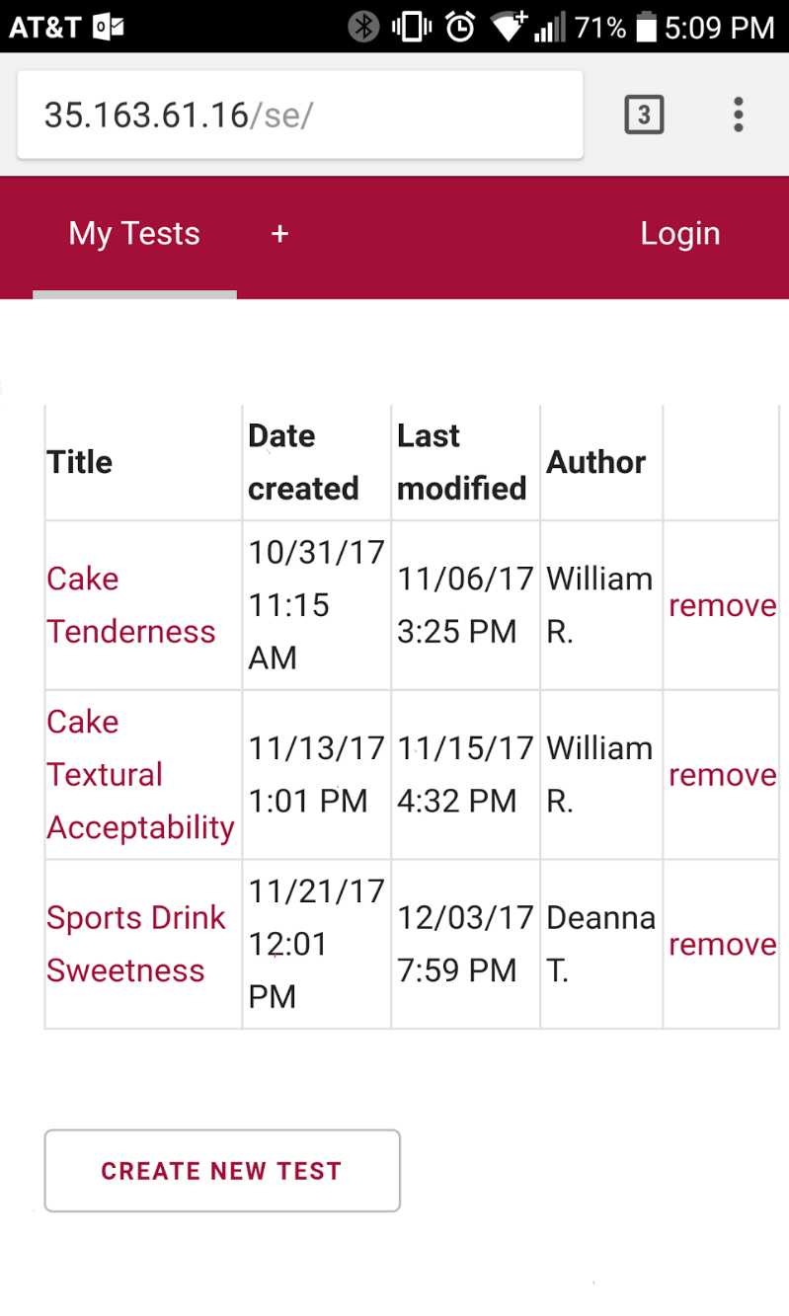

**Document C**

This is a screen shot of the main page on the website we are creating. This screen shot was taken on an iPad in the Safari browser.

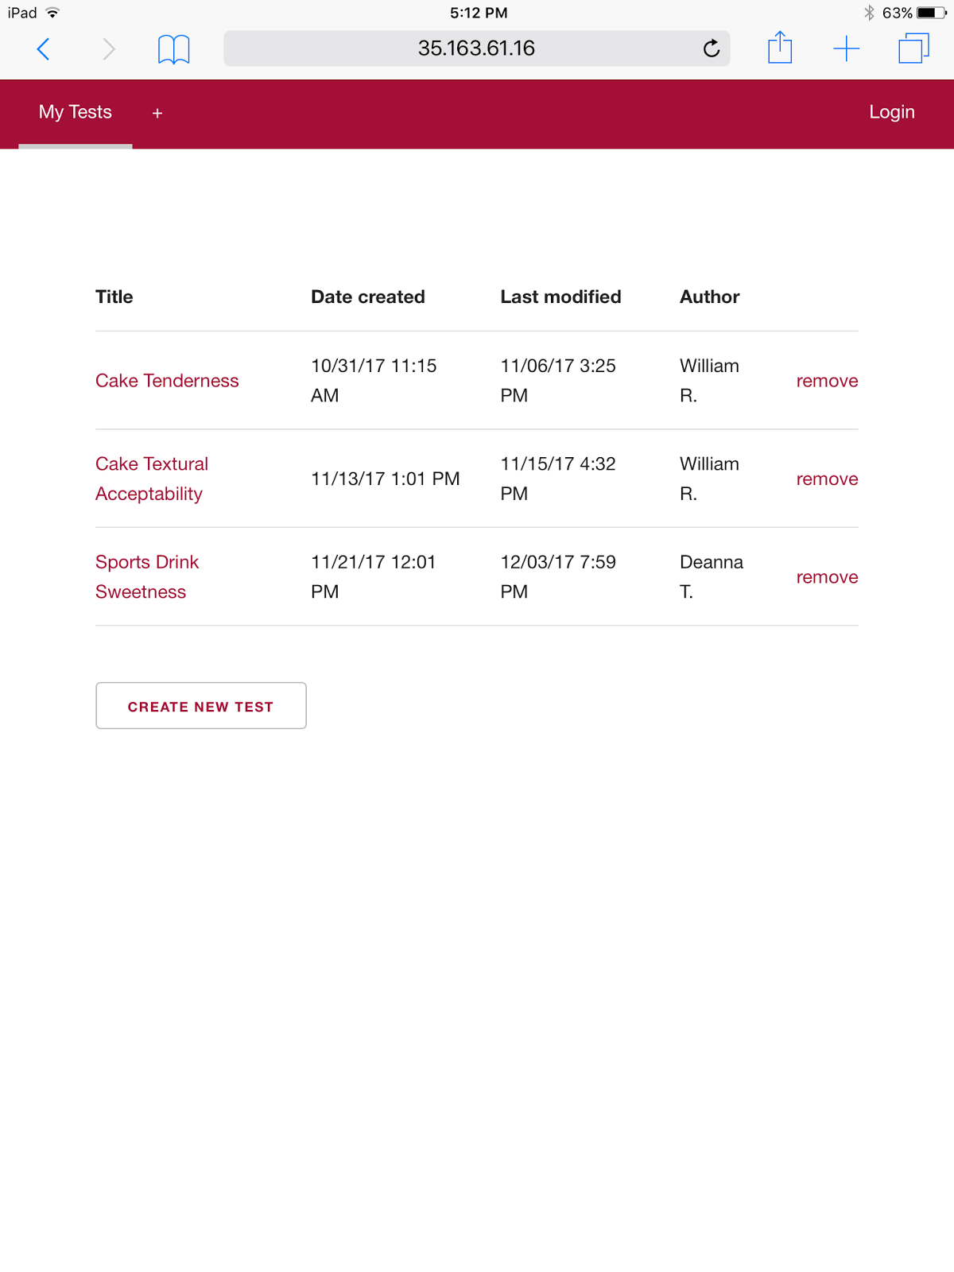

**Document D**

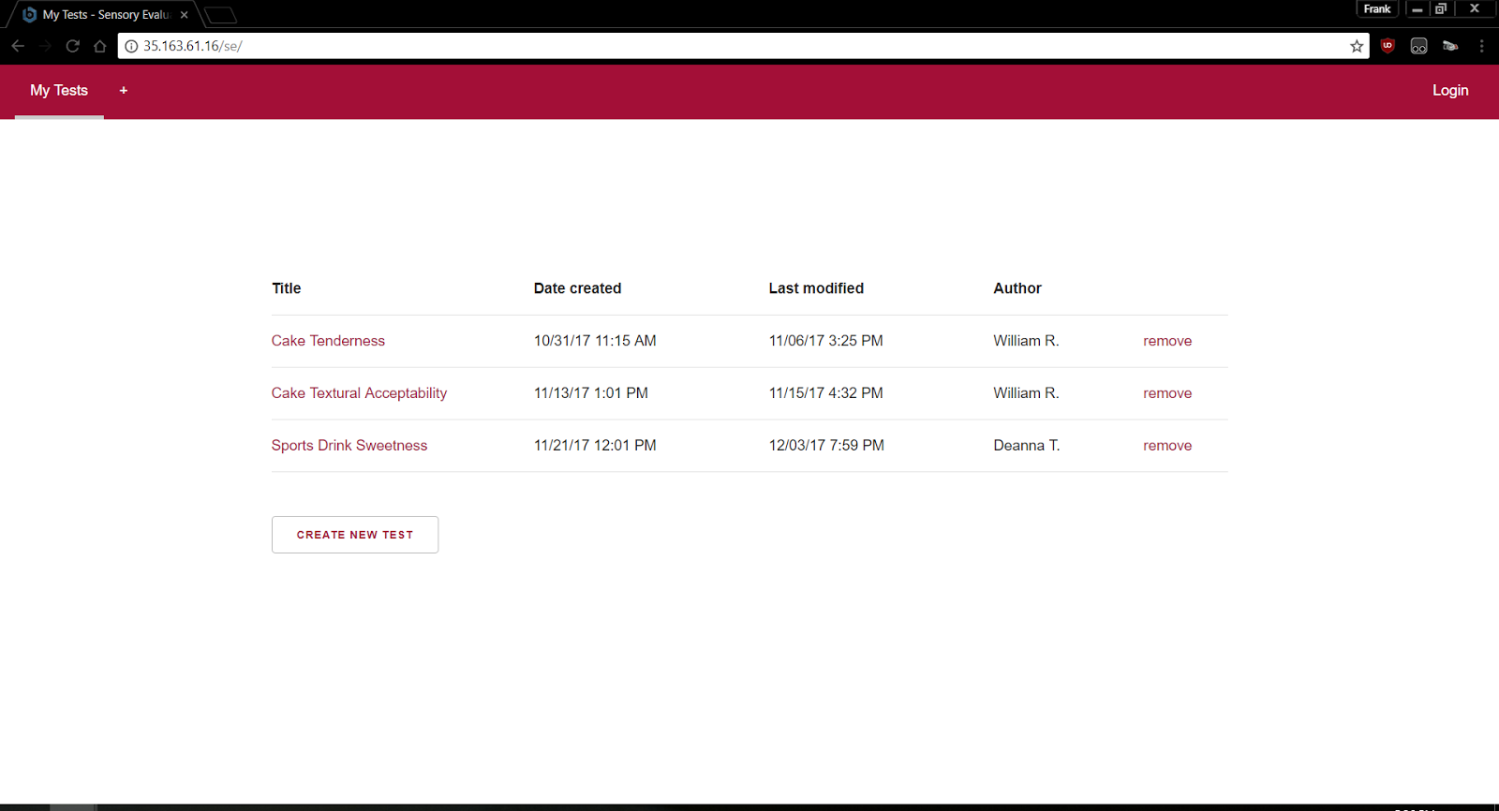This is a screen shot of the main page on the website we are creating. This screen shot was taken on a computer in the Chrome browser.